PRACTICAL NO: 03(B)

Topic: Perform ARP Poisoning in Windows

Date: 15/01/2020

Step 1: Open Cain and Abel tool.



Step 2: Click on Arp tool and click next button.

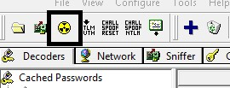

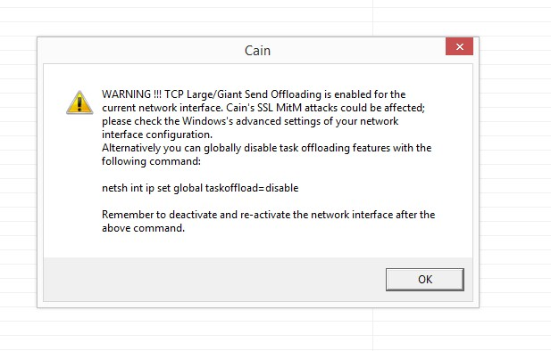

Step 3: Click on sniffer . Right click select (scan mac address)

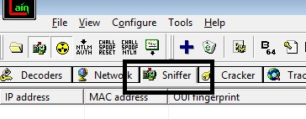

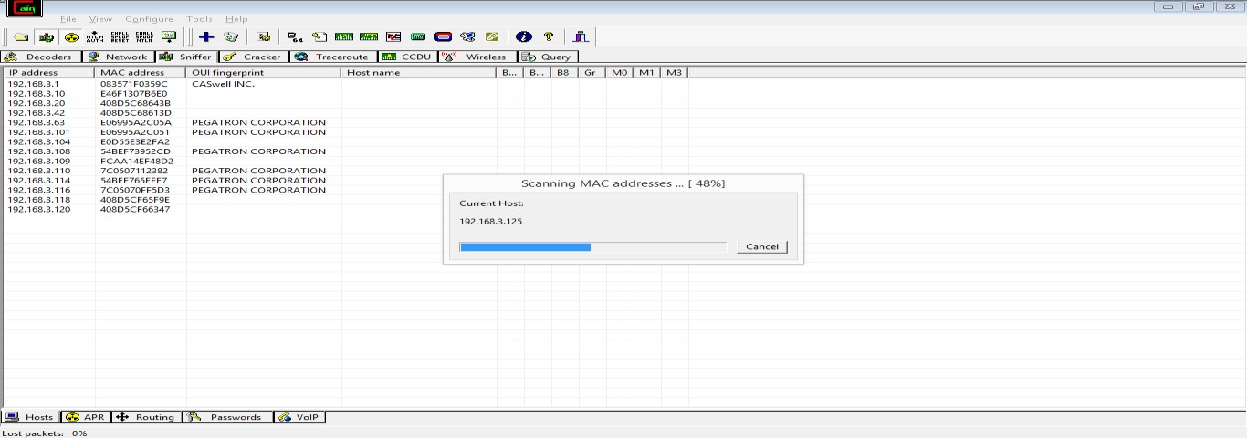

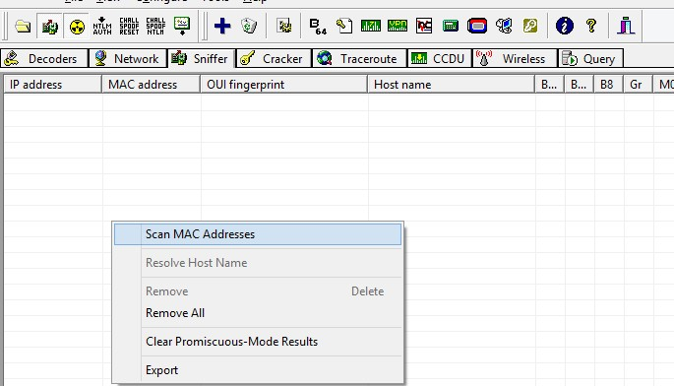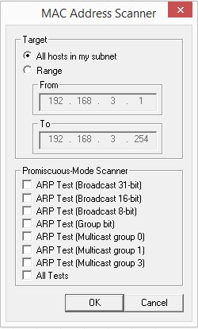

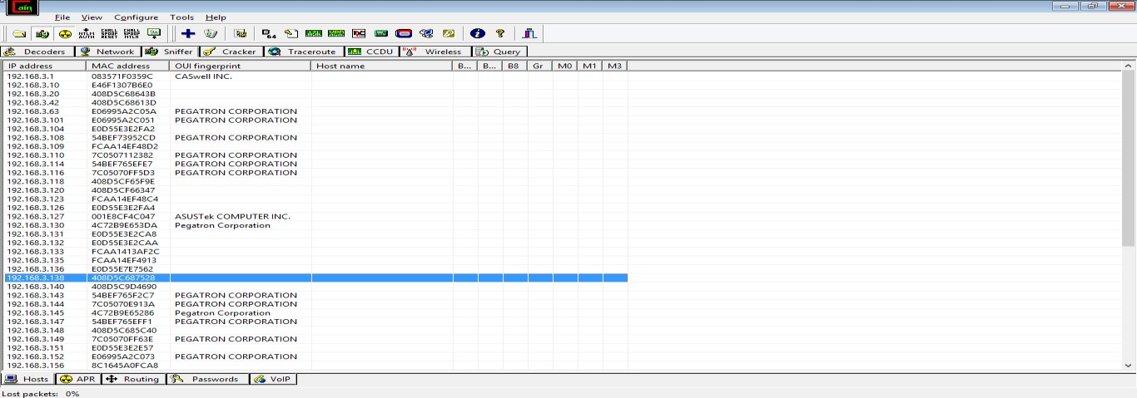

Click on ARP . Add new ARP poising routing.

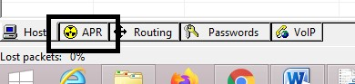

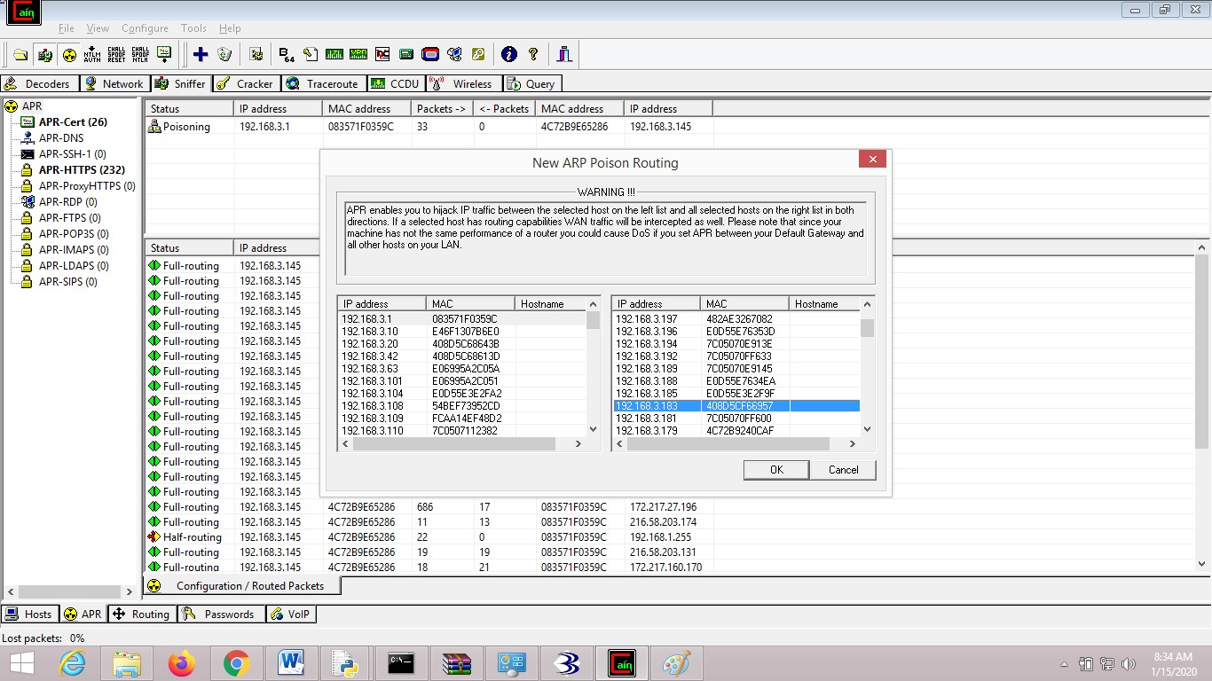

Select Arp and click on poisoning.

Click Passwords ->HTTP->Check username and password.

